9/9/2023

Mayowa Bamiro

Justit

Assignment 1 Data Visualization

Mayowa Bamiro

**Contents**

**Assignments Requirements**

* Table contents1
* Policies and Procedures2
* Password Protect screenshots3

**First Task**

Policies and Procedures2

**Second Task**

Excel4-5

The Data 6-7

Table into Chart8-9

**Third Task**

Creating Macros10-11

Tableau12

**Reflective Task**

Reflective Essay13-14

**Policies and Procedures when dealing with Data.**

**What is a data protection policy?**

Data protection policy is how your organisation handles, organises, and protects personal data. It is a collection of principles, rules, and guidelines that help you guarantee ongoing compliance with data protection laws.

**Data Protection Policy in the UK**

The Data Protection Act 2018 is the UK’s implementation of the General Data Protection Regulation (GDPR). This means everyone and organizations should follow strict rules called ‘data protection principles.’ They must make sure the information is: used fairly, lawfully, and transparently.

**Why is it important to adhere to GDPR?**

The law states that anyone responsible for collecting data must handle it with care and it should be confidential it is important that the right procedures of storing such sensitive data is taken seriously because if personal data falls into the wrong hands people could be harmed. Depending on the situation they may be a victim of physical abuse, identity theft or discrimination.

**What happens if you don’t comply with GDPR?**

Businesses could risk serve penalties and if fail to comply with GDPR requirements. You could also face a fine up to millions of pounds, and a ruined reputation and business.

**How to password protect your workbook screenshot**

**Click on the Review tab followed by Protect Workbook**

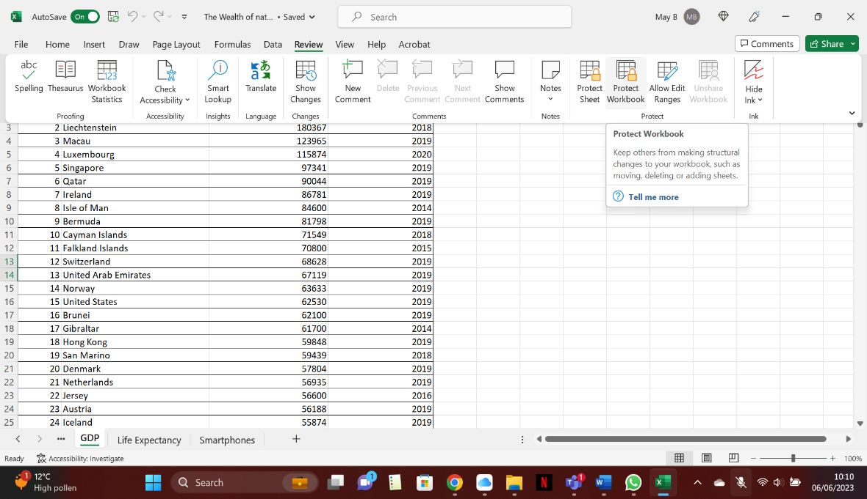

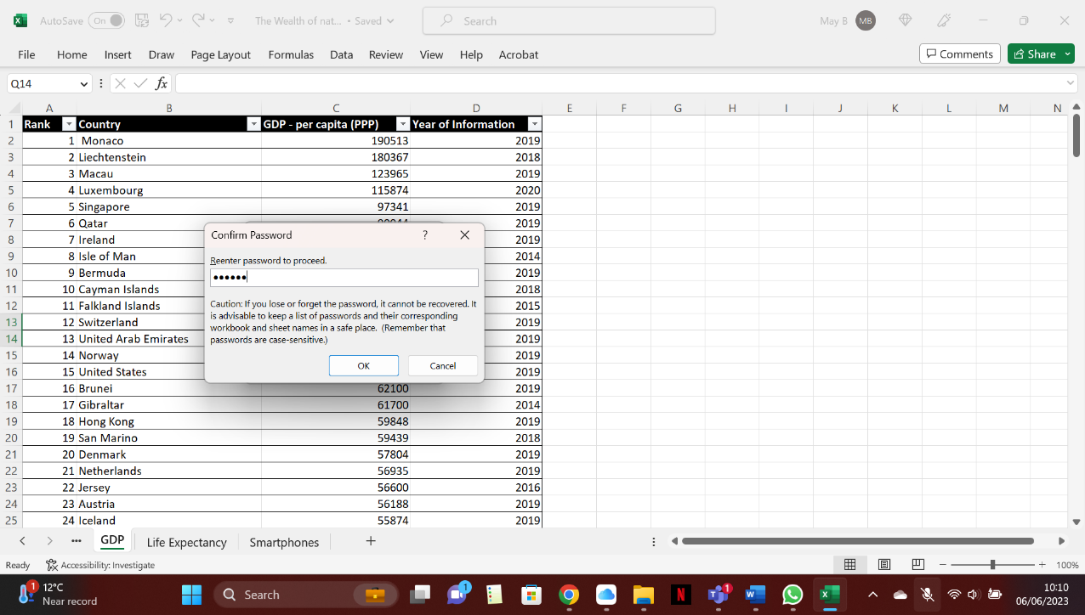

**Insert your password then proceed to confirm to protect your workbook.**

**Second task in excel.**

**Highlight column C then in Home tab press number.**

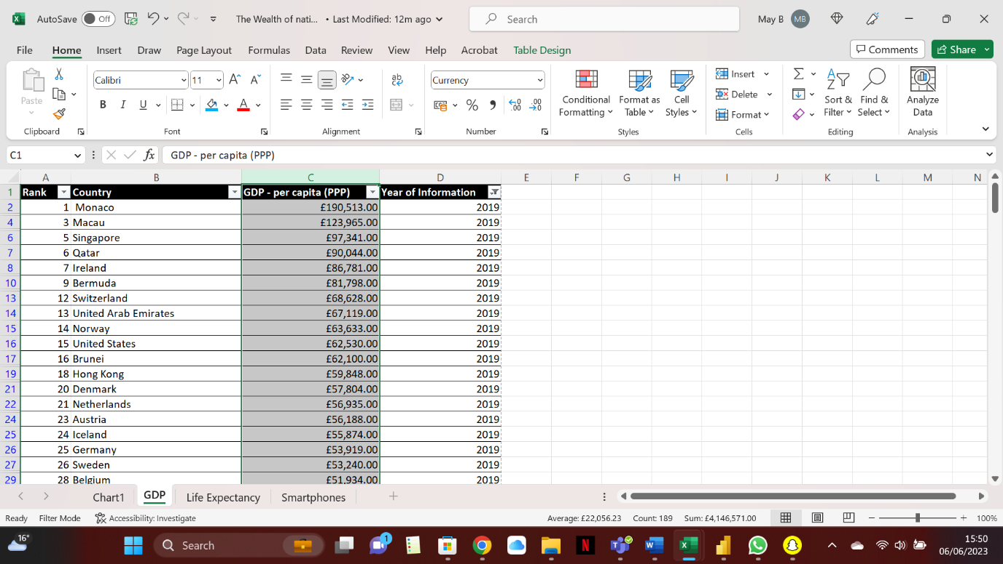

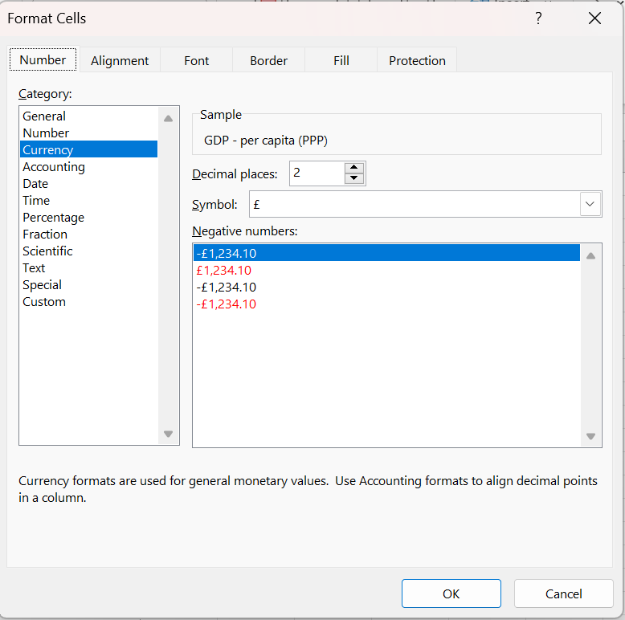

**When in Format Cells box scroll down to currency and find the £ symbol in symbol box**

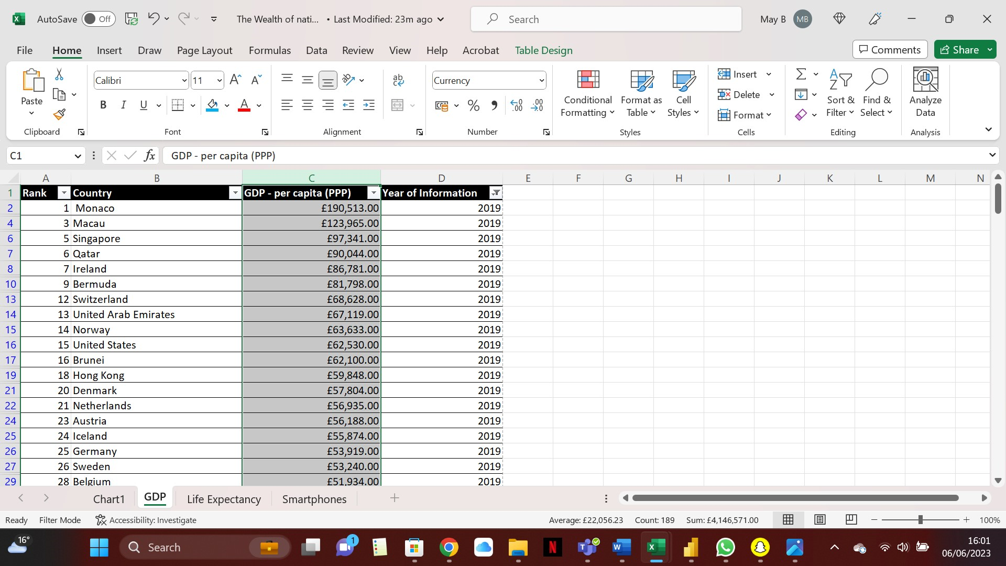

**Result of Column C in currency**

**Press ok to apply the £ symbol throughout column C**

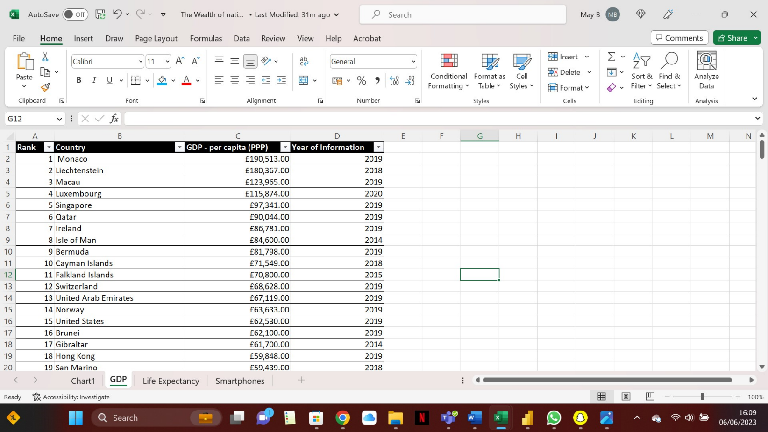

**In the Year of information click the drop-down tool and filter only 2019**

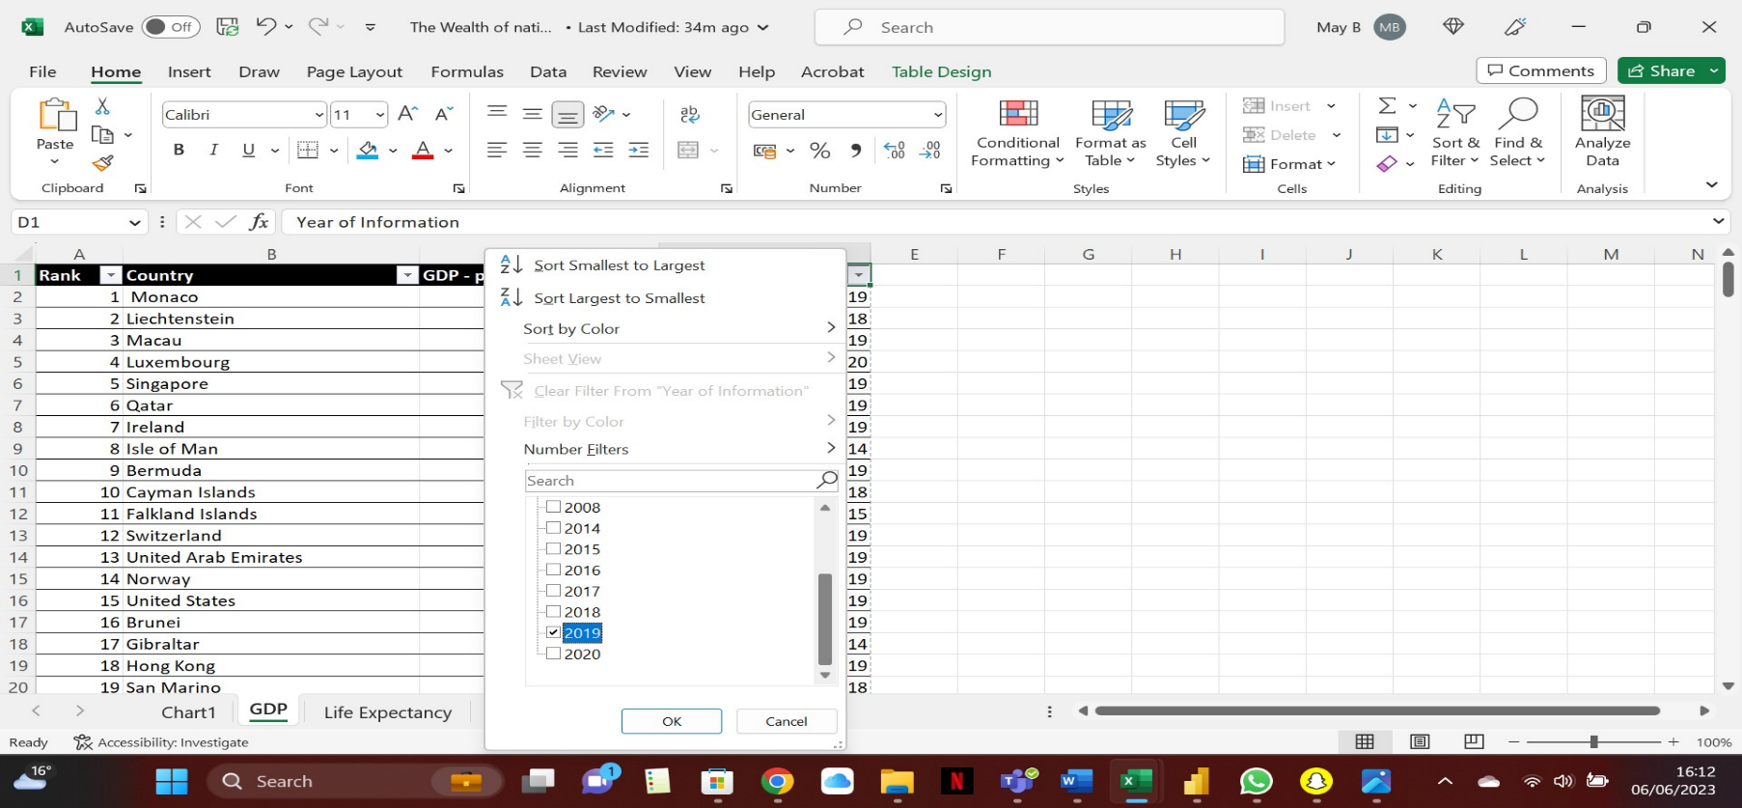

**Press OK below to filter only results from 2019.**

**Deselect all then check only the 2019 box**.

**Making a table in excel screenshots**

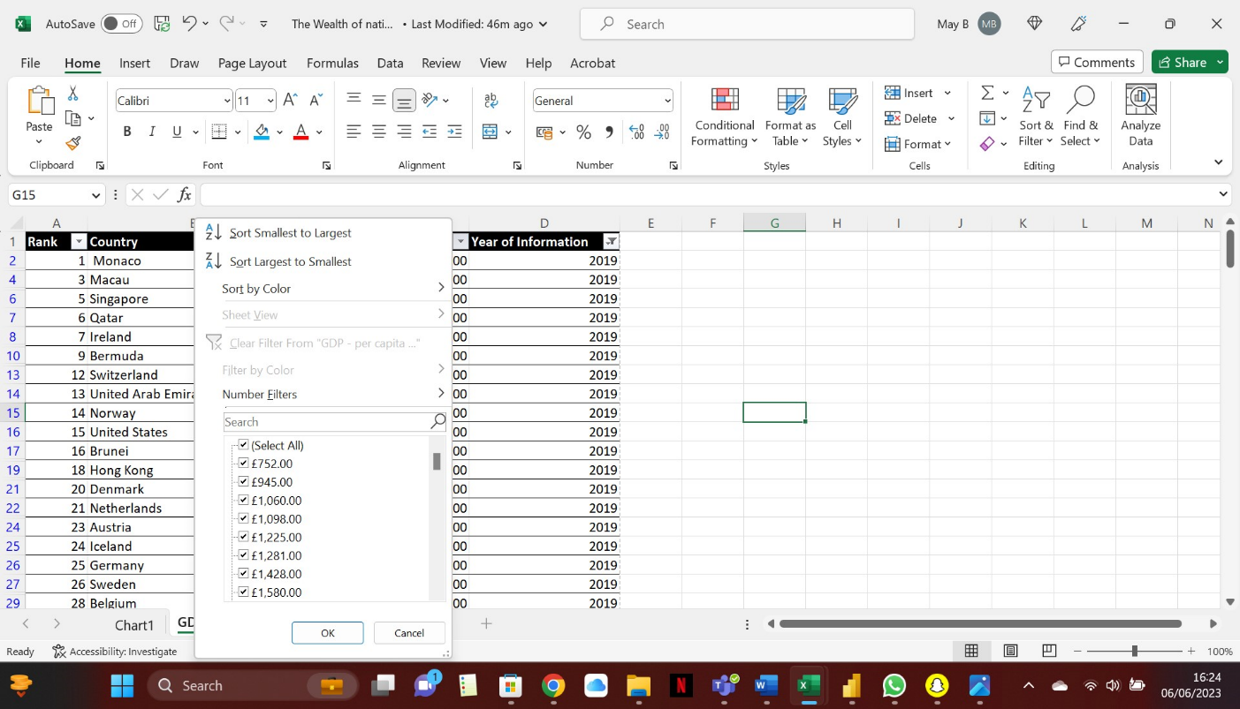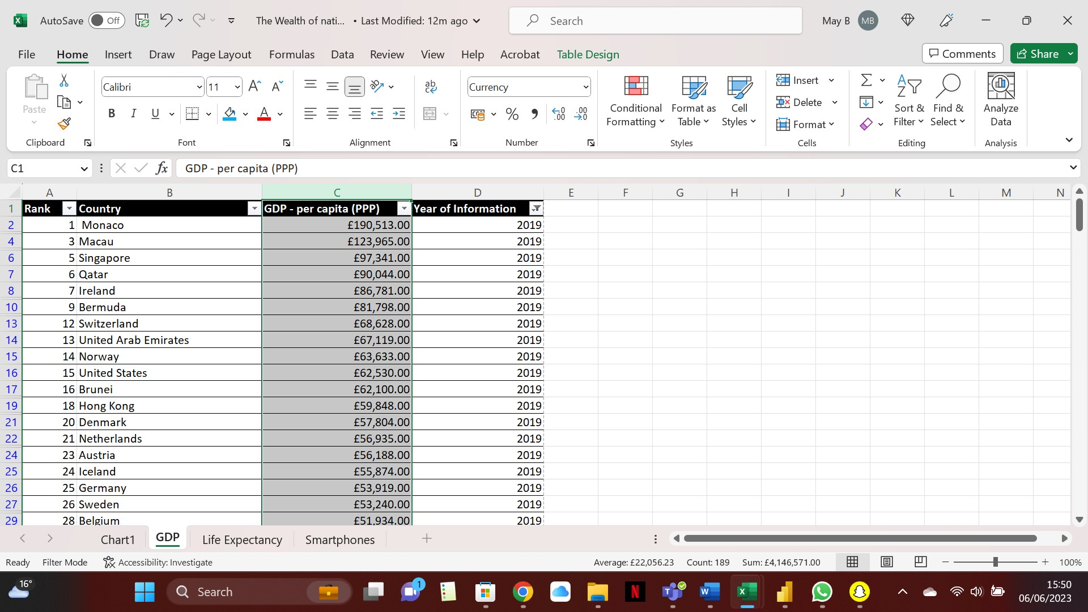

**Select the drop-down box in column C**

**Scroll down to Number Filters**

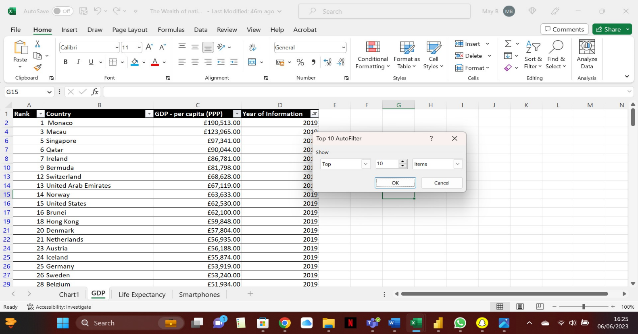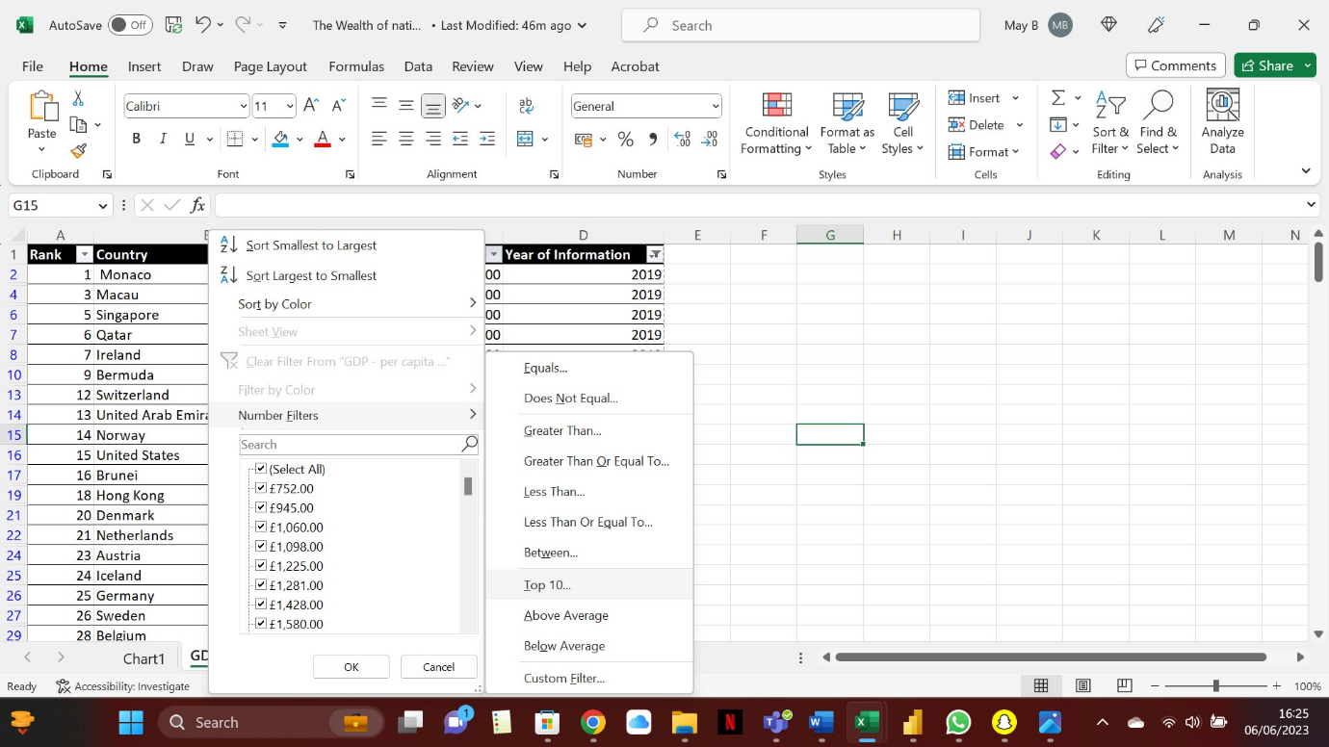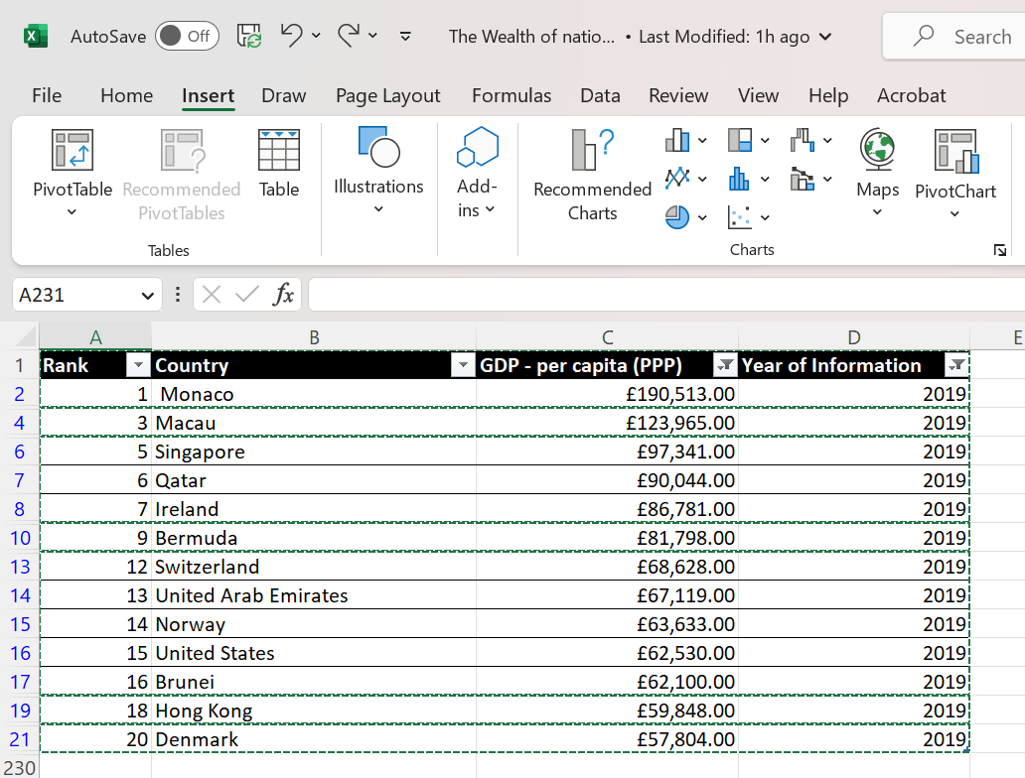

**Create a table by copying contents and clicking table from Insert tab.**

**Scroll up to 20 then press the OK button to apply the Top 20 results.**

**Select Top 10**

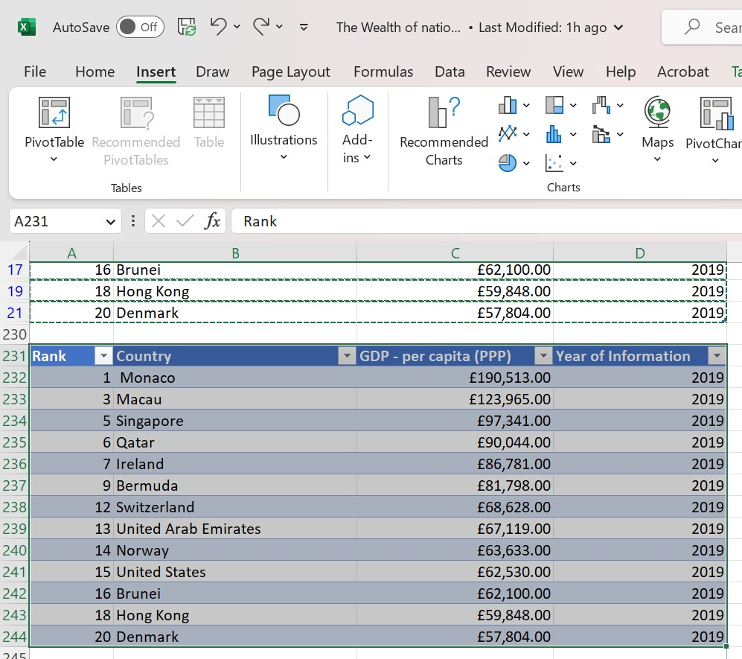

Select the whole contents of the data you want to visualize in your graph.

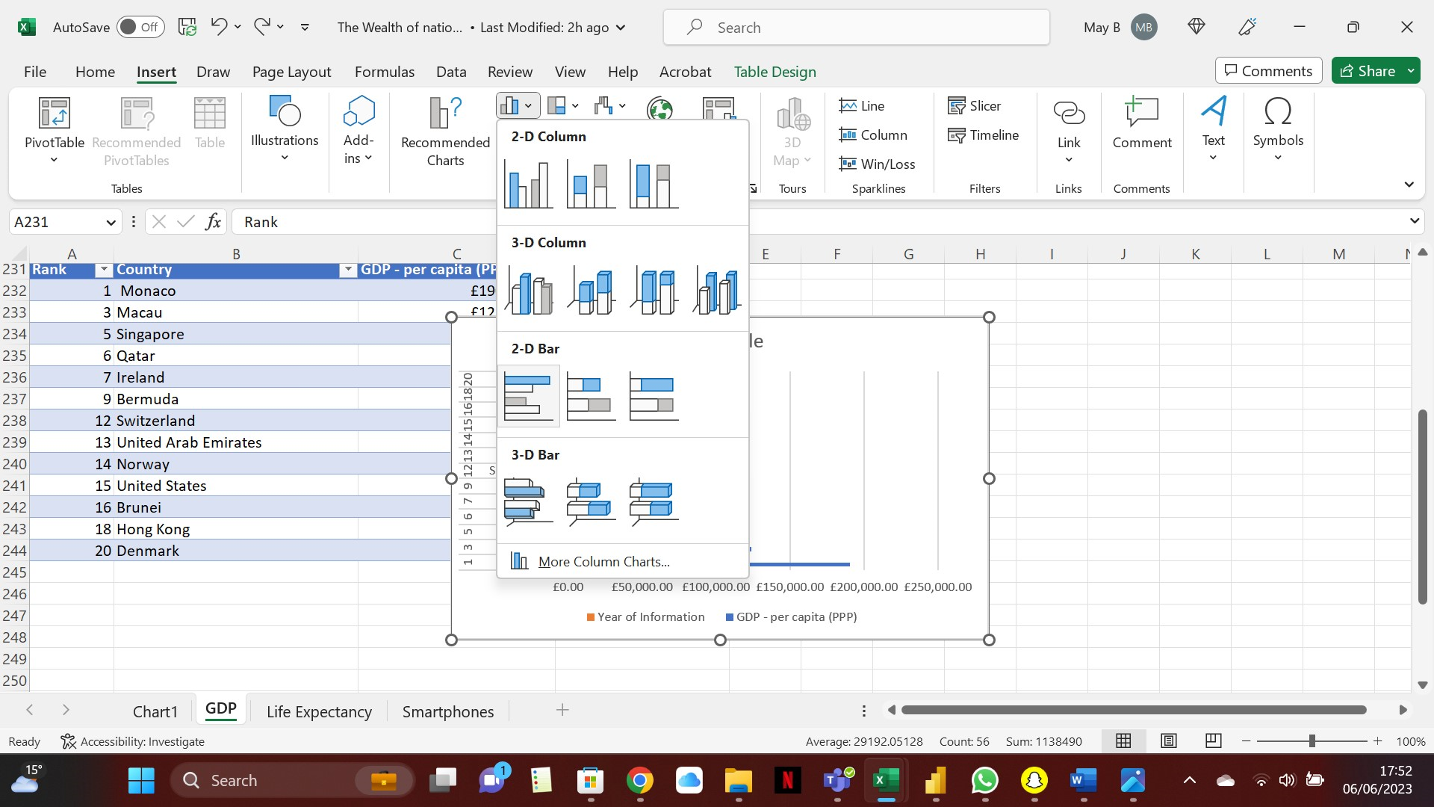

**In the Insert tap choose the graph you want then press enter**

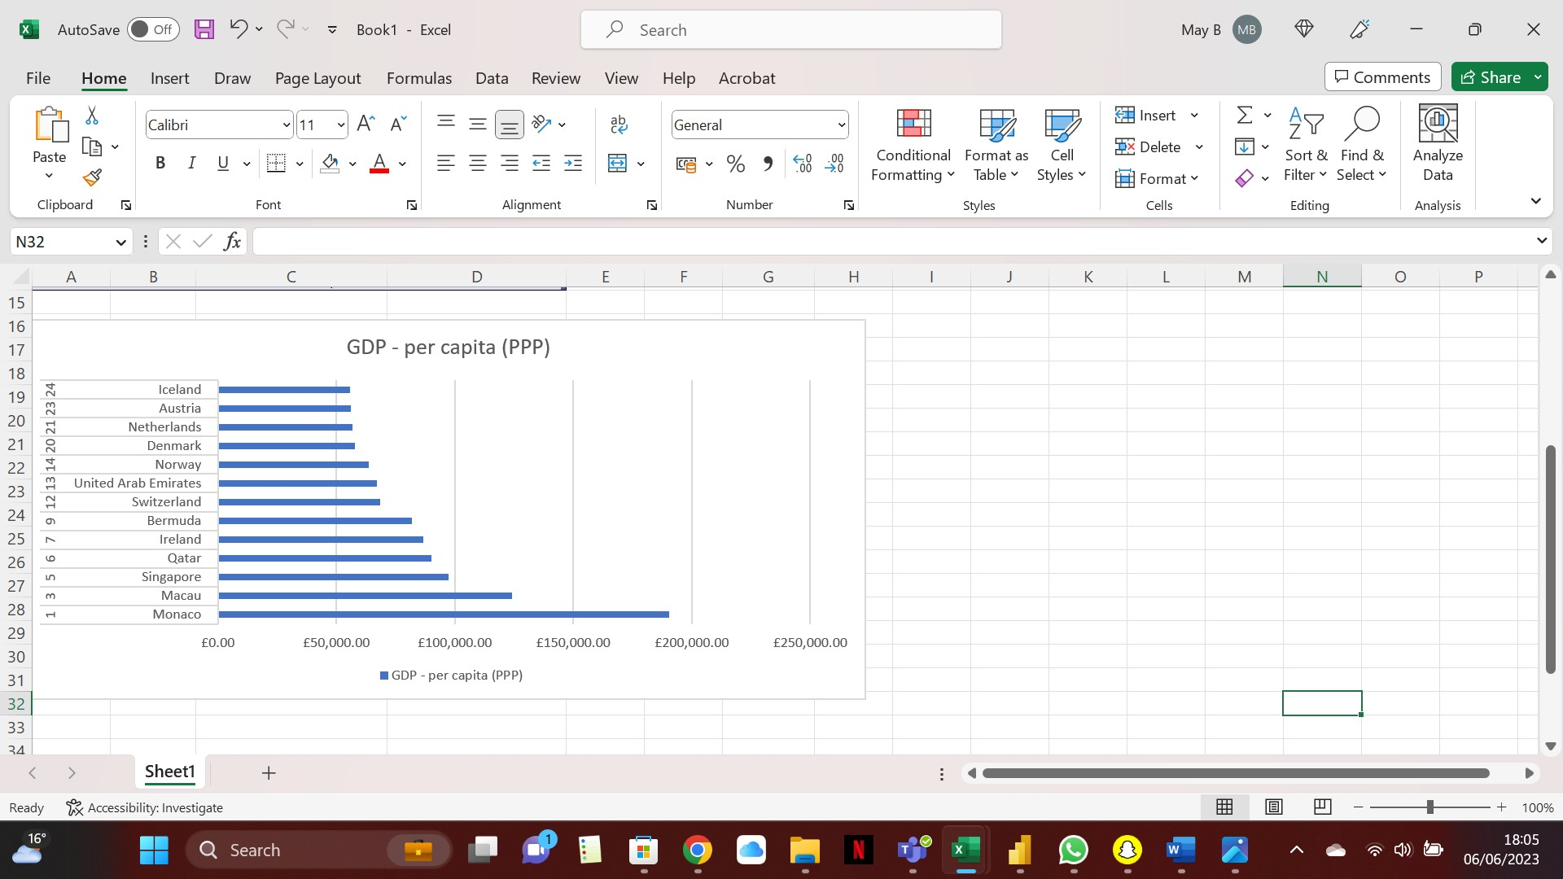

**The result of the Bar Chart**

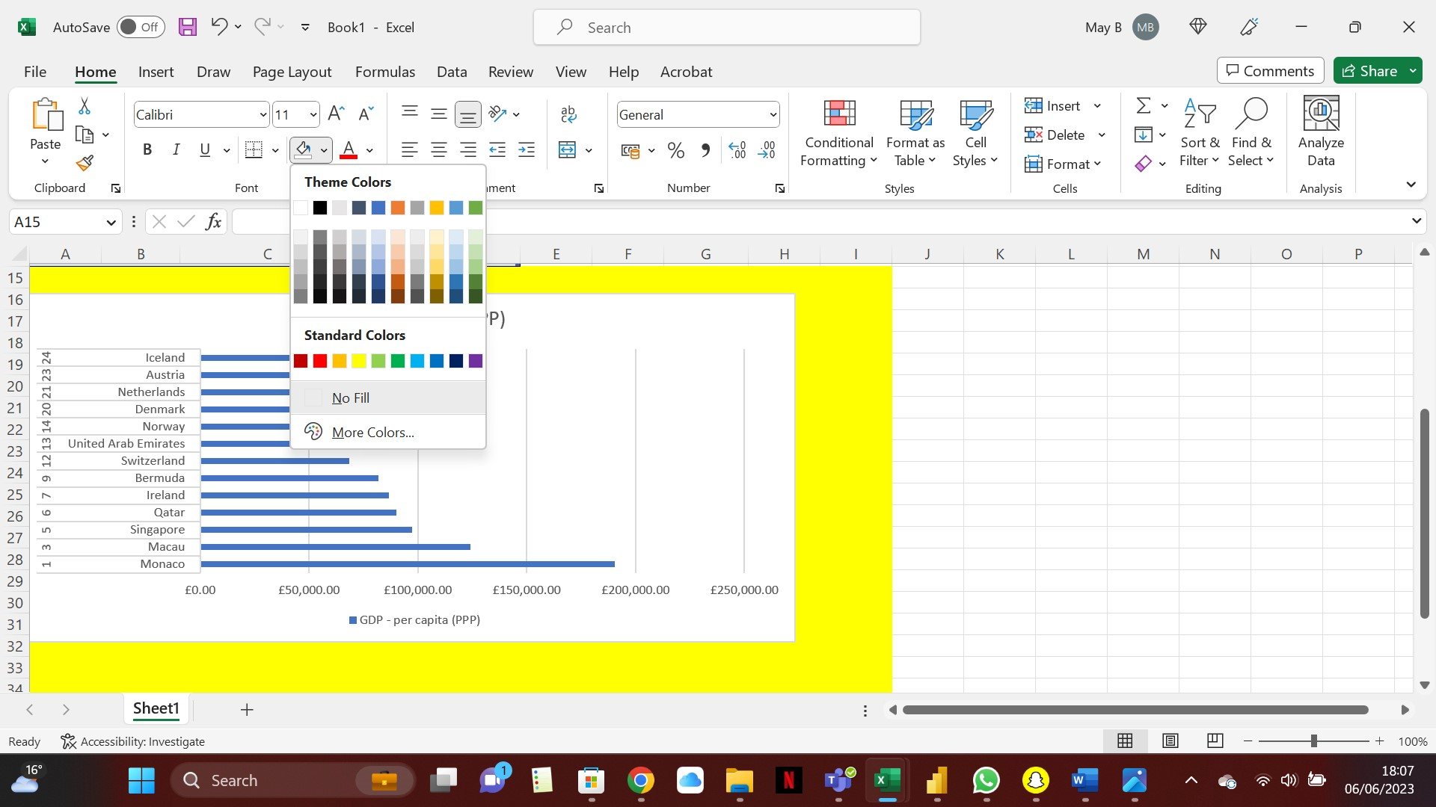

**Under Home tab press background fill colour.**

**Highlight the area underneath the bar chart.**

**Creating Macros**

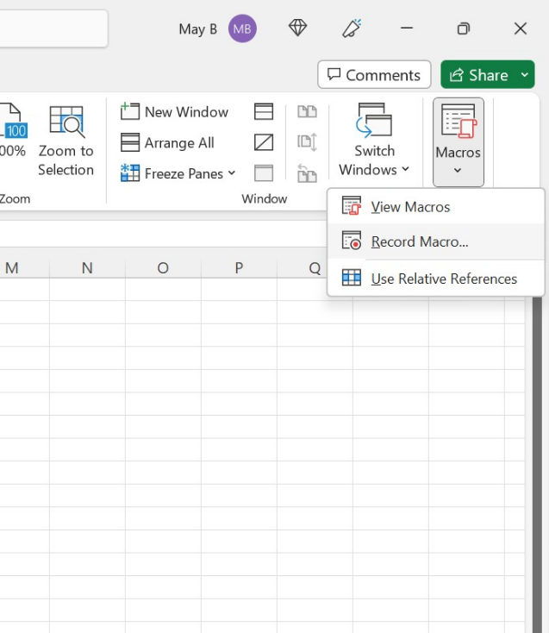

Click on Macro in **VIEW** tab then press record macro.

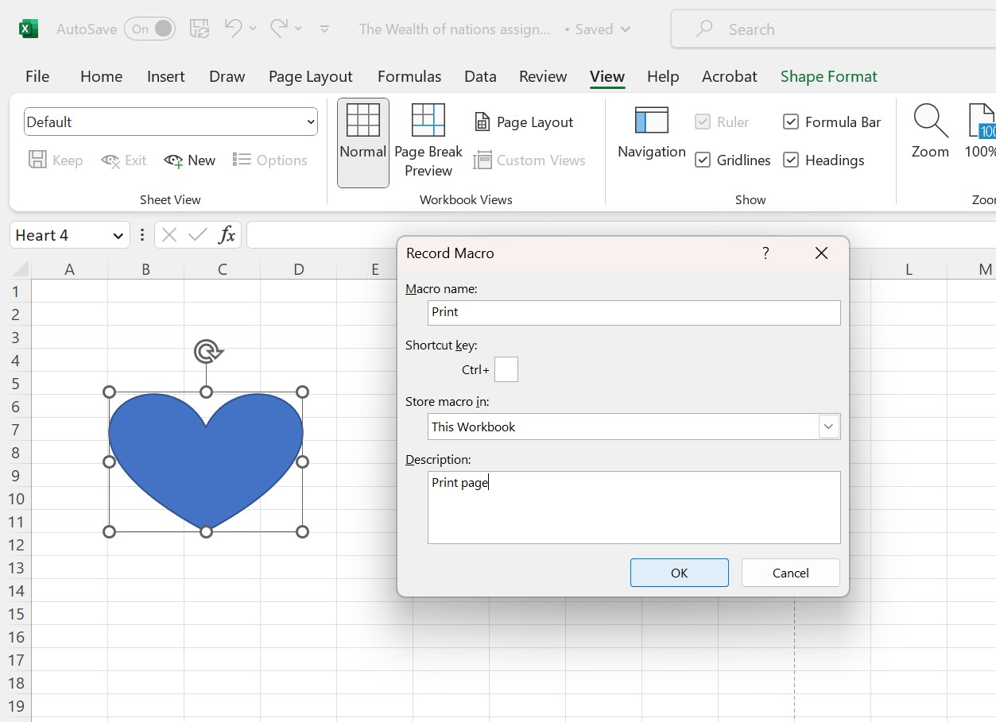

Write in text box what you want your macro to be called.

Press **OK** to begin the recording process.

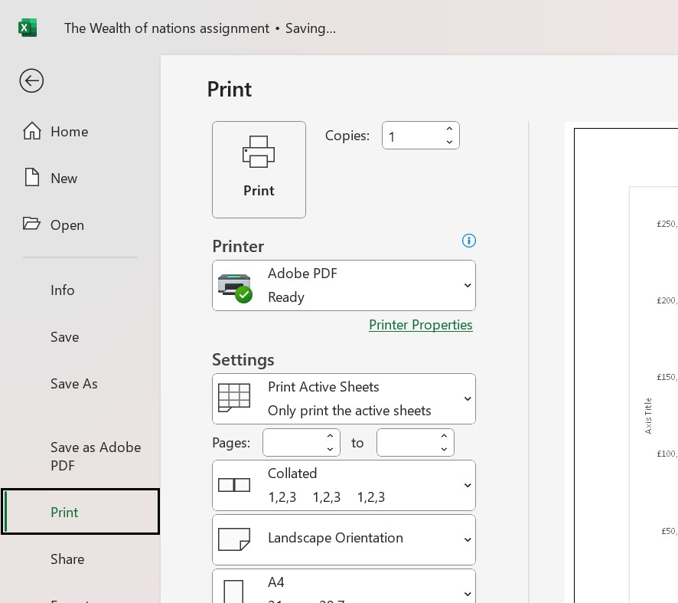

Press Print action to record your Macro.

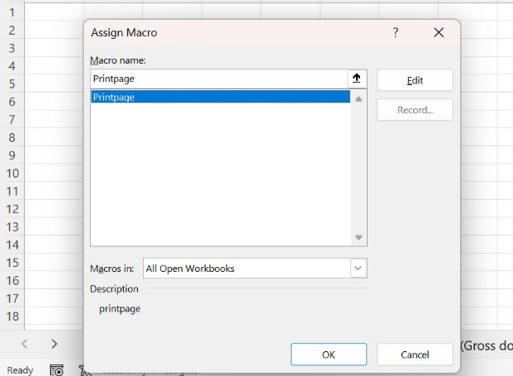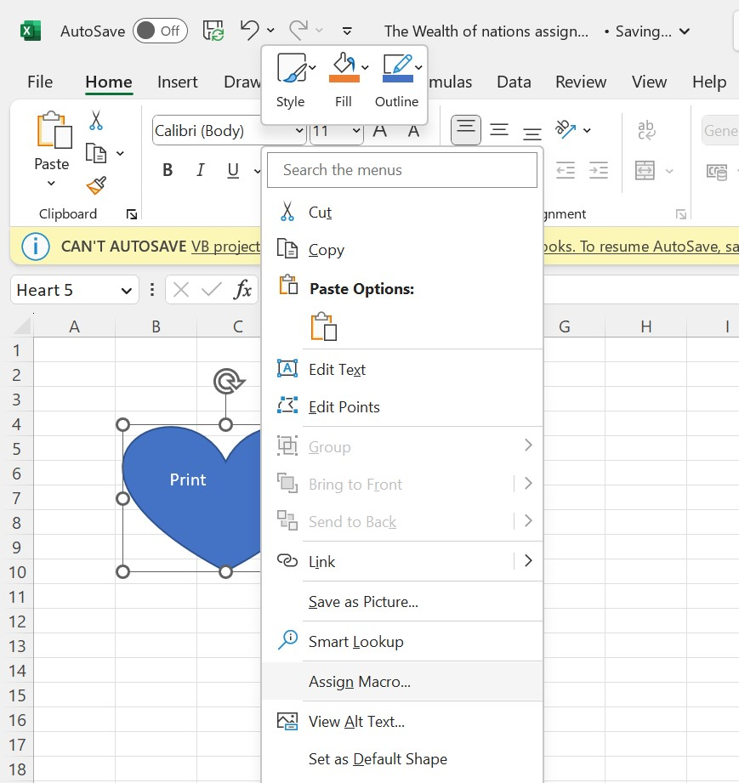

Create any shape then right click and assign print to the shape.

Press Printpage to prescribe that macro to your chosen shape

**Header and Footer completed for excel**

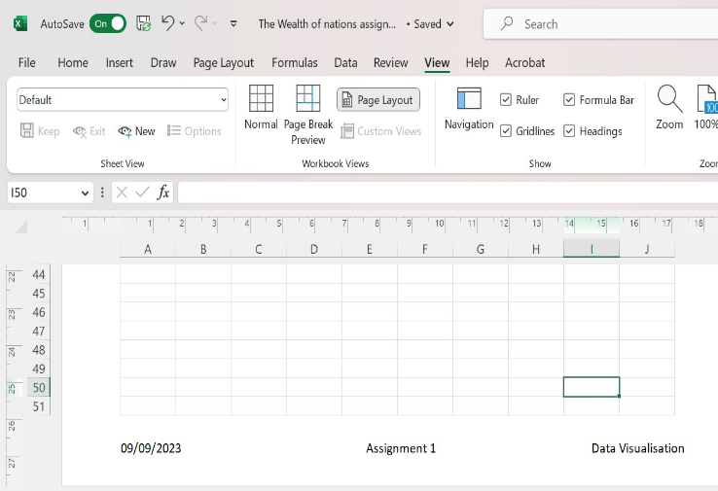

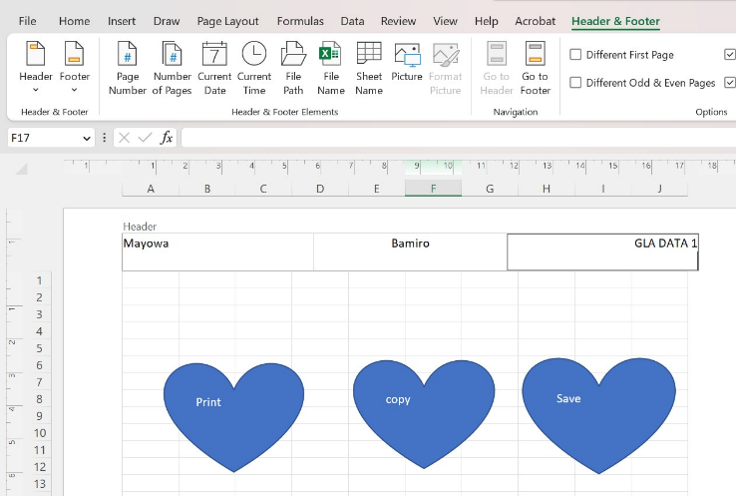

**Tableau Dashboard**

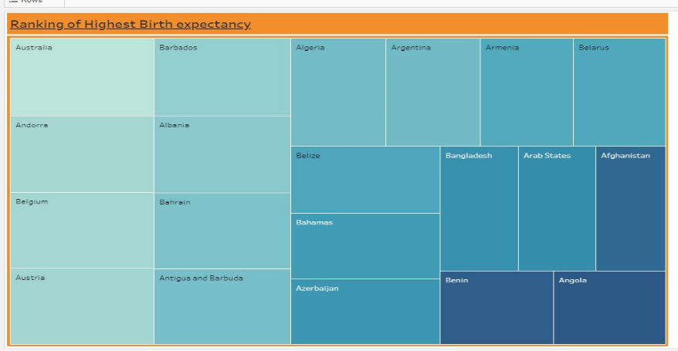

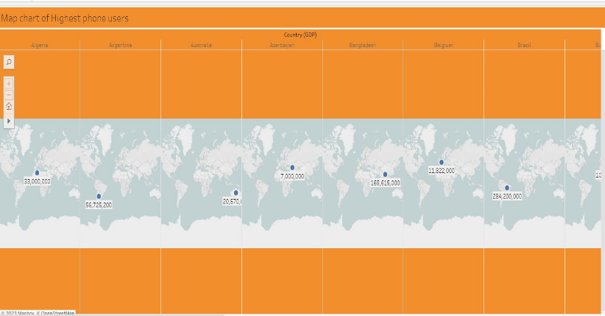

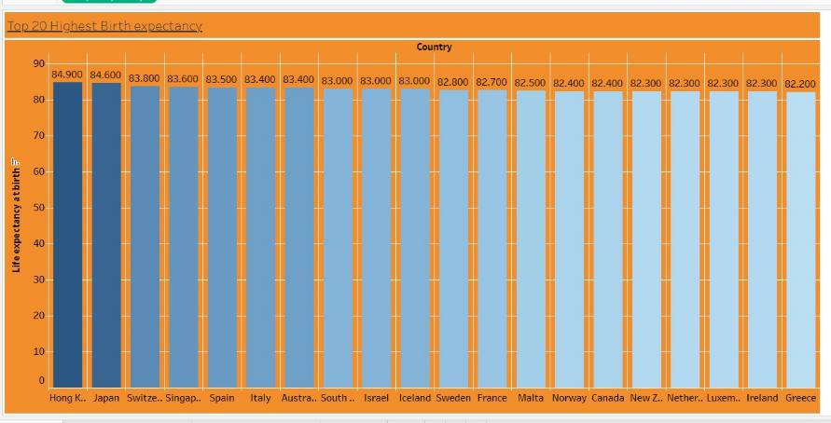

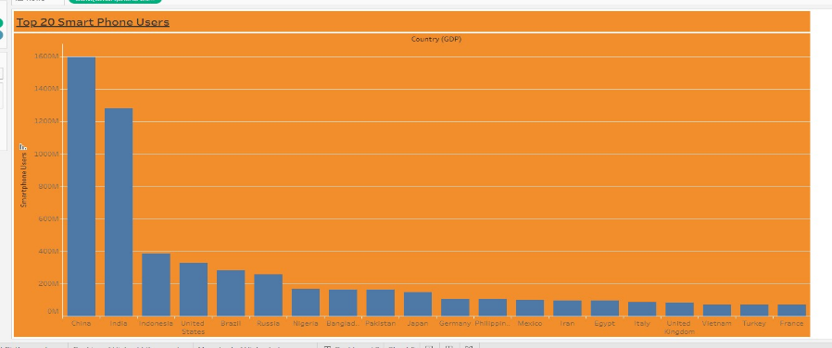

**Link to Tableau Dashboard: https://public.tableau.com/app/profile/mayowa.bamiro/viz/TheWealthofNations_16862614942530/Dashboard2**

**Reflective Essay**

***What did I learn during the course?***

During my JustIT course I learnt how to use multiple visualisation software and excel. This was great as it helped me build my knowledge and understanding more on these analyzation tools. I learnt how to clean data and input data in software such as tableau or PowerBi correctly I also learnt how to set relationships between different tables something I haven’t done before which was very interesting and powerful. I also discovered how to save and publish my visualisation on tableau and PowerBi this is extremely useful to me as I’m able to go back to my projects and see what I was able to create, and others could also view my work too. Learning all of things helped me to gain more insight of these software’s I was also able to express my creativity when it comes to visualisation which I believe is important as I would love for my dashboards to look professional and elegantly made.

***What difficulties did I experience with whilst working with different software?***

There were a few setbacks when working with different software such as Tableau I believe when you’re not working with the data for a long time you have to refresh it and also having software that is online or downloaded is completely different too. When I had downloaded software straight to my laptop it was easier to follow instructions as the instructor is using the same format whilst if I was using an online version, it may have been a bit more complex as it there may have been some tools that were either missing or placed in a different section which could lead to setbacks and delays when performing such tasks.

***How did I overcome such difficulties?***

I overcome such difficulties by speaking to my instructor after lesson with any concerns I faced during the lesson and asking for further assistance with any work. I also simply Google the tasks and find YouTube tutorials on data cleaning or using tableau etc. The other way I asked for guidance is speaking to other members in the teams group chat to see if they had any suggestions on what could be done to overcome my problem. Lastly, is self-learning I would often go back and practice things that I felt were difficult so that I can increase my understanding on the use of data cleaning on making dashboards by just perfecting my own work or playing around with such visualization tools to see what they could do to my draft work.

***How will I improve for future assignments or work tasks?***

I will improve by time managing my work tasks, I feel as though I don’t get enough time to work on projects which causes me to rush and give in mediocre work. Next time I would take time out of my day to perfect my work and ask for feedback by sending in drafts of my work and getting my tutor to look at it and give me suggestions of how I could improve. I will also try breaking down what exactly I need to do in my future assignments by working on different pieces during the week hence I get a more productive piece of work that is made with greater intention and up to great standards. The most important thing is for me is to also practice working more on data sets with tableau and PowerBi as I have forgotten most steps to make my dashboards and visuals look cleaner and more professional.